Class Assignment 1: Socket Programming(Assignment)

In this assignment, you’ll write a client that will use sockets to communicate with a server that you will also write. Here’s what your client and server should do:

Your client should first accept an integer between 1 and 100 from the keyboard, [M1] open a TCP socket to your server and send a message containing (i) a string containing your name (e.g., “Client of John Q. Smith”) and (ii) the entered integer value and then wait for a sever reply.

Your server will create a string containing its name (e.g., “Server of John Q. Smith”) and then [M2] begin accepting connections from clients. On receipt of a client message, your server should
- [M3] print (display) the client’s name (extracted from the received message) and the server’s name
- itself pick an integer between 1 and 100 (it’s fine for the server to use the same number all the time) and display the client’s number, its number, and the sum of those numbers
- [M3] send its name string and the server-chosen integer value back to the client
- if your server receives an integer value that is out of range, it should terminate after releasing any created sockets. You can use this to shut down your server.
[M4] Your client should read the message sent by the server and display its name, the server’s name, its integer value, and the server’s integer value, and then compute and the sum. The client then terminates after releasing any created sockets. As an aside (and as a check that you are doing things correctly, you should make sure for yourself that the values and the sums are correct!)
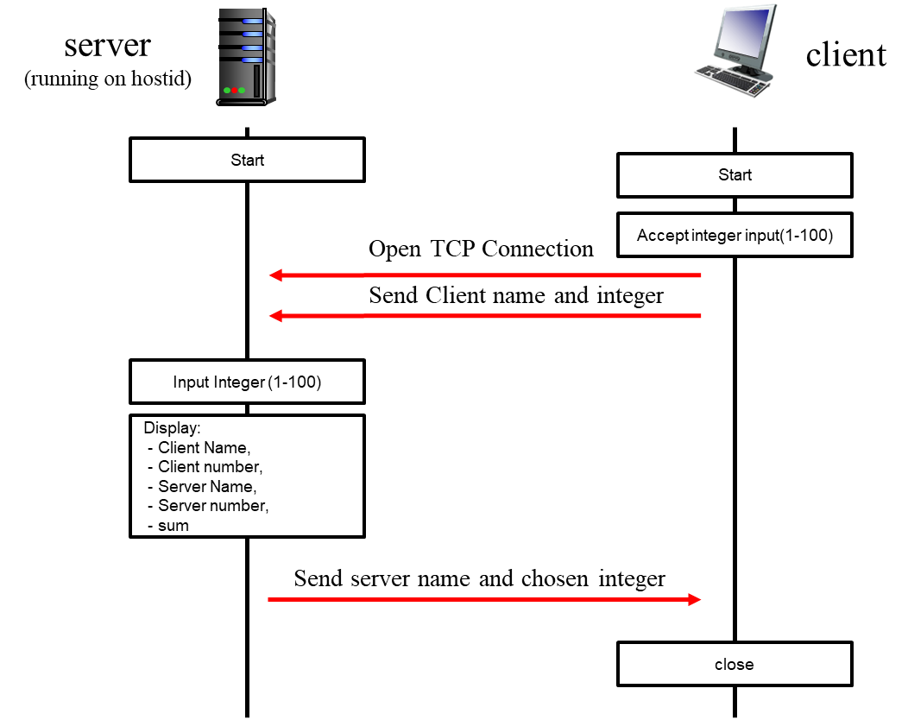
OK. You've got the basic assignment done. The last part of the assignment should be a fun, social thing to do. Team up with someone from the class and get your client to interact with their server or vice versa. If you’ve got a server up and running, you can advertise your server’s services to anyone in the class (you’re not allowed to charge for service!), and if you’ve got a client, all you need to do is interact with such an advertised server.

Note that if you’ve got your own client and server running, there isn’t any more programming involved – just running your client and server with someone else’s. This shouldn’t actually be very hard at all! For this part of the assignment, you need only hand in the output from your “wide” – the client or the server, since you’ll be printing out the name of the other student’s client or server with whom your client or server is interacting. Recall that when we discussed RFC standards for protocols we noted that the IETF requires that two independent implementations of a protocol must interoperate; that’s what you are doing here. Again, make sure to check that your numbers and sums are correct.

Please read the information posted on the class LMS site and pdf files about what to hand with your assignment.
Note that you should draw diagram of you own refrencing diagram presented in assignment pdf. You should program your client and server to each print an informative statement whenever it takes an action (e.g., sends or receives a message, detects termination of input, etc.), so that you can see that your processes are working correctly (or not!). This also allows the TA to also determine from this output if your processes are working correctly. You should hand in screen shots (or file content, if your process is writing to a file) of these informative messages as well as the required output of the client and server (name strings, integer values and sums). And also, you need to analyze about packets which can be seen in Wireshark.

Programming Languages and Operating Systems
You may write your programs in Java, C++, Python, or C on any platform (Liux/unix, Mac, PC) you want; you have accounts in the edlab. Other languages are OK, but ask me first. You can do this assignment on a linux/unix computer, a Mac or a PC. See http://www.lowtek.com/sockets/ for links to tutorials on the WINSOCK API, which we haven’t covered in class.

Programming the assignment in JAVA

- Our discussion in class focused on the Java API, but you can use Python if you prefer. Details about the socket class, and the other classes noted below, can be found at https://docs.oracle.com/en/java/javase/22/docs/api/java.base/java/net/Socket.html
- Java encapsulates the concept of a server-side connection-oriented socket with the class, ServerSocket. You'll need to use the accept() and close(0) methods of this class, which are also document at this URL.
- If you're interested in a quick Java tutorial targeted specifically at socket programming, check out "Socket Programming in Java: a tutorial," by Q. Mahmoud, Javaworld, Dec. 1996, http://www.javaworld.com/javaworld/jw-12-1996/jw-12-sockets_p.html. Sun's socket tutorial is at http://java.sun.com/docs/books/tutorial/networking/sockets/index.html.
- Mission 0: Before follow following the missions:
  - Draw Block diagram of TCP Client and TCP Server
  - Draw Flow chart for TCP Client and TCP Server
- Mission 1: Open TCP Socket to connect with Server and send a message
  - Fill#1, Initializing client-side socket to connect to Server
  - Fill#2, Read an integer from the user to make a message to send
  - Fill#3, Send the client name and the entered integer to the server
- Mission 2: Open TCP Socket to receive message from client
  - Fill#4, Initializing the server on a specified port
  - Fill#5, Listen for a TCP connection request.
  - Fill#6, Read message from client
- Mission 3: Extract client's name and integer from message and send calculated message to client
  - Fill#7, Calculate and print the sum of the client's and server's numbers
  - Fill#8, Send server's name and chosen number back to the client
- Mission 4: Extract the server's chosen integer from the response and Calculate the sum of the client’s and server’s numbers
  - Fill#8, Read and print the response from the server
  - Fill#9, Calculate and print the sum of the client's and server's numbers
  - Fill#10, Close socket

Skeleton Code for Mission

Below you will find the skeleton code for the TCP Server and TCP Client. And also build the Block diagram to learn the architecture of the simple socket program,

TCPClient.java (Make Block diagram of TCP Client)

package socket_programming;

import java.io.*;
import java.net.*;

class TCPClient {
public static void main(String argv[]) throws Exception {
String host = "localhost"; // Server address
int port = 8888; // Server port number

// Mission 1: Open TCP Socket to connect with Server and send a message
//Fill#1, Initializing client-side socket to connect to Server
Socket clientSocket = /*Fill in the Blank*/; // Mission 1

DataOutputStream outToServer = new
BufferedReader inFromUser = new BufferedReader(new InputStreamReader(System.in));

DataOutputStream(clientSocket.getOutputStream());
BufferedReader inFromServer = new BufferedReader(new InputStreamReader(clientSocket.getInputStream()));

// Fill#2, Read an integer from the user to make a message to send
System.out.print("Enter an integer between 1 and 100: ");
int userNumber = /*Fill in the Blank*/; // Mission 1

// Fill#3, Send the client name and the entered integer to the server
String clientMessage = "Client of John Q. Smith: " + userNumber;
/*Fill in the Blank*/; // Mission 1

// Mission 4: Extract the server's chosen integer from the response and Calculate the sum of the client’s and server’s numbers
// Fill#8, Read and print the response from the server
String serverMessage = /*Fill in the Blank*/; //Mission 4
System.out.println("FROM SERVER: " /*Fill in the Blank*/); //Mission 4

// Extract the server's chosen integer from the response
String[] parts = serverMessage.split(": ");
String serverName = parts[0];
int serverNumber = Integer.parseInt(parts[1]);

// Fill#9, Calculate and print the sum of the client's and server's numbers
int sum = /*Fill in the Blank*/; //Mission 4
System.out.println("Client number: " + /*Fill in the Blank*/); //Mission 4
System.out.println("Server number: " + /*Fill in the Blank*/); //Mission 4
System.out.println("Sum: " + /*Fill in the Blank*/); //Mission 4
// Fill#10, Close socket
/*Fill in the Blank*/;
}
}

TCPServer.java(Make Block diagram of TCP Server)

package socket_programming;

import java.io.*;
import java.net.*;

class TCPServer {
public static void main(String argv[]) throws Exception {
String serverName = "Server of John Q. Smith"; // Server name
int port = 8888; // Server port number

// Mission 2: Open TCP Socket to receive message from client
// Fill#4, Initializing the server on a specified port
ServerSocket welcomeSocket /*Fill in the Blank*/; //Mission 2

while (true) {
// Fill#5, Listen for a TCP connection request.
Socket connectionSocket = /*Fill in the Blank*/; //Mission 2
BufferedReader inFromServer = new BufferedReader(new InputStreamReader(System.in));

BufferedReader inFromClient = new BufferedReader(new InputStreamReader(connectionSocket.getInputStream()));
DataOutputStream outToClient = new DataOutputStream(connectionSocket.getOutputStream());

// Fill#6, Read message from client
String clientMessage = /*Fill in the Blank*/; //Mission 2
System.out.println("Received: " + clientMessage);
// Mission 3: Extract client's name and integer from message and send calculated message to client
// Extract client's name and integer
String[] parts = clientMessage.split(": ");
String clientName = parts[0];
int clientNumber = Integer.parseInt(parts[1]);

System.out.print("Enter an integer between 1 and 100: ");
int serverNumber = Integer.parseInt(inFromServer.readLine());

// Fill#7, Calculate and print the sum of the client's and server's numbers
int sum = /*Fill in the Blank*/; // Mission 3
System.out.println("Client number: " + /*Fill in the Blank*/);
System.out.println("Server number: " + /*Fill in the Blank*/);
System.out.println("Sum: " + /*Fill in the Blank*/);

// Fill#8, Send server's name and chosen number back to the client
String serverMessage = /*Fill in the Blank*/; // Mission 3
outToClient.writeBytes(/*Fill in the Blank*/); // Mission 3

// Terminate the server if the client sends a number outside the range of 1 to 100
if (clientNumber < 1 || clientNumber > 100) {
connectionSocket.close();
welcomeSocket.close();
break;
}
}
}
}

Programming the assignment in C

If you choose to write your programs in C, you'll need to master the C system calls needed for socket programming. Perosnally, C is my favorite language for network programming since it gets you closest to the operating system’s socket-related system calls. These include socket(), bind(), listen(), accept(), connect(), and close(). For a quick text-only tutorial of socket programming specifically under Linux, see http://www.lowtek.com/sockets/. Here’s another nice tutorial: http://beej.us/guide/bgnet/

Programming the assignment in Python.

The 6th edition of the text (and what we’ve discussed in class) uses sockets in Python. A Python socket tutorial is http://docs.python.org/howto/sockets.html

Programming notes

Here are a few tips/thoughts to help you with the assignment:

- You must chose a server port number greater than 1023 (to be safe, choose a server port number larger than 5000). If you want to explicitly choose you client-side port, also choose a number larger than 5000.
- You may need to know your machine's IP address, when one process connects to another. You can telnet to your own machine and seeing the dotted decimal address displayed by the telnet program. You can also use the UNIX nslookup command . On Windows, see the ipconfig utility. On a Mac, you can run the terminal program and use the ifconfig commend (just type in ifconfig or ifconfig | grep "inet ").
- Many of you will be running the clients and senders on the same UNIX machine (e.g., by starting up the receiver and running it in the background, then starting up the relay in the background, and then starting up the sender. This is fine; since your using sockets for communication these processes can run on the same machine or different machines without modification. Recall the use of the ampersand to start a process in the background. If you need to kill a process after you have started it, you can use the UNIX kill command. Use the UNIX ps command to find the process id of your server
- Make sure you close every socket that you use in your program. If you abort your program, the socket may still hang around and the next time you try and bind a new socket to the port ID you previously used (but never closed), you may get an error. Also, please be aware that port ID's, when bound to sockets, are system-wide values and thus other students may be using the port number you are trying to use.

For extra credit, rewrite your server to be a concurrent server - that is a server that waits on the welcoming socket and then creates a new thread or process to handle the incoming request (i.e., carry out the username verification and message-of-the-day protocol described above). If you're doing the assignment in C, you'll need to learn about the fork() system call. Here is an example that will get you going: http://www.tutorialspoint.com/unix_sockets/socket_server_example.htm If you're doing the assignment in Java, see the section "Supporting Multiple Clients" in Sun's socket programming tutorial, http://java.sun.com/docs/books/tutorial/networking/sockets/clientServer.html. Here’s a page that will get you started that will get you started in Python: http://ilab.cs.byu.edu/python/threadingmodule.html and http://www.eurion.net/python-snippets/snippet/Threaded%20Server.html. If you find better pages for C, Java or Python, please share with the class!

Extra Programming notes
- What is different with TCP&UDP? Speed, reliability, stream(vs datagram), and else?

Reliability: TCP is reliable, UDP is unreliable.
Speed: TCP is slow, UDP is fast
Stream: TCP provides stream control and congestion control mechanisms, which can adjust the sending speed according to network conditions to avoid network congestion. UDP does not provide stream control and congestion control, so it will not actively reduce the sending speed.
Datagram: TCP does not have a strict single data packet size limit, but most TCP implementations usually divide larger data streams into several segments, each of which does not exceed the MTU.
The maximum size of a single UDP datagram is 65,535 bytes, but in order to avoid IP fragmentation, it is usually controlled within the MTU.

- Following is UDP example codes, complete this mission with UDP.
  - Is this program proper to build with UDP? What is the String point? And what is the Weak point?
  - I think it is not suitable because the task of transmitting and adding numbers requires accuracy. The advantage of UDP is its fast speed, but its accuracy is insufficient.
- Server-Client vs Peer to Peer structure?
Server-Client communication is one-way, the client initiates the request and the server responds. The direction and process of communication are predetermined.
P2P communication is two-way, and any node can be the sender or receiver of data. There is no central server, and nodes can communicate directly with each other to form a dynamic, peer-to-peer network relationship.
- Try to build Peer to Peer structure
- import java.net.*;
- import java.io.*;

- public class P2PNode{
- public static void main(String[] args) throws Exception {

- new Thread(new P2PServer()).start();

- new Thread(new P2PClient()).start();
- }
- }

- class P2PServer implements Runnable {
- public void run() {
- try {
- ServerSocket serverSocket = new ServerSocket(8888);
- System.out.println("P2P node is waiting for connections...");
- while (true) {
- Socket connectionSocket = serverSocket.accept();
- BufferedReader inFromClient = new BufferedReader(new InputStreamReader(connectionSocket.getInputStream()));
- String clientMessage = inFromClient.readLine();
- System.out.println("Received: " + clientMessage);
- connectionSocket.close();
- }
- } catch (Exception e) {
- System.out.println("Server error: " + e.getMessage());
- }
- }
- }

- class P2PClient implements Runnable {
- public void run() {
- try {
- Thread.sleep(1000);
- Socket clientSocket = new Socket("localhost", 8888);
- DataOutputStream outToServer = new DataOutputStream(clientSocket.getOutputStream());
- outToServer.writeBytes("Hello from P2P client\n");
- clientSocket.close();
- } catch (Exception e) {
- System.out.println("Client error: " + e.getMessage());
- }
- }

Project Example #0: Building a Socket Server & Client
Name: Wang Yuexiao
Student ID: 2019048240
Organization: Department of computer science and engineering, Hanyang Univ. (Seoul, Republic of Korea)

Introduction
This project implements a client-server calculator based on TCP. The client connects to the server, sends an integer, and the server generates its own integer. The server then responds with the client's integer and the server's integer, and the sum of the two values ​​is calculated and displayed on both ends.
Contents of the attachment
Source code:TCPClient.java
import java.io.*;
import java.net.*;

class TCPClient {
public static void main(String argv[]) throws Exception {
String host = "localhost"; // Server address
int port = 888; // Server port number

// Mission 1: Open TCP Socket to connect with Server and send a message
// Fill#1, Initializing client-side socket to connect to Server
Socket clientSocket = new Socket(host, 8886);/*Fill in the Blank*/; // Mission 1

BufferedReader inFromUser = new BufferedReader(new InputStreamReader(System.in));
DataOutputStream outToServer = new DataOutputStream(clientSocket.getOutputStream());
BufferedReader inFromServer = new BufferedReader(new InputStreamReader(clientSocket.getInputStream()));

// Fill#2, Read an integer from the user to make a message to send
System.out.print("Enter an integer between 1 and 100: ");
int userNumber = Integer.parseInt(inFromUser.readLine());/*Fill in the Blank*/; // Mission 1

// Fill#3, Send the client name and the entered integer to the server
String clientMessage = "Client of John Q. Smith: " + userNumber;
outToServer.writeBytes(clientMessage + "\n");
/*Fill in the Blank*/; // Mission 1

// Mission 4: Extract the server's chosen integer from the response and Calculate the sum of the client’s and server’s numbers
// Fill#8, Read and print the response from the server
String serverMessage = inFromServer.readLine();/*Fill in the Blank*/; //Mission 4
System.out.println("FROM SERVER: " + serverMessage/*Fill in the Blank*/); //Mission 4

// Extract the server's chosen integer from the response
String[] parts = serverMessage.split(": ");
String serverName = parts[0];
int serverNumber = Integer.parseInt(parts[1]);

// Fill#9, Calculate and print the sum of the client's and server's numbers
int sum = userNumber + serverNumber;/*Fill in the Blank*/; //Mission 4
System.out.println("Client number: " + userNumber/*Fill in the Blank*/); //Mission 4
System.out.println("Server number: " + serverNumber/*Fill in the Blank*/); //Mission 4
System.out.println("Sum: " + sum/*Fill in the Blank*/); //Mission 4
// Fill#10, Close socket
clientSocket.close();
/*Fill in the Blank*/;
}
}

TCPServer.java
import java.io.*;
import java.net.*;

class TCPServer {
public static void main(String argv[]) throws Exception {
String serverName = "Server of John Q. Smith"; // Server name
int port = 8886; // Server port number

// Mission 2: Open TCP Socket to receive message from client
// Fill#4, Initializing the server on a specified port
ServerSocket welcomeSocket = new ServerSocket(port);/*Fill in the Blank*/; //Mission 2

while (true) {
// Fill#5, Listen for a TCP connection request.
Socket connectionSocket = welcomeSocket.accept();/*Fill in the Blank*/; //Mission 2
BufferedReader inFromServer = new BufferedReader(new InputStreamReader(System.in));

BufferedReader inFromClient = new BufferedReader(new InputStreamReader(connectionSocket.getInputStream()));
DataOutputStream outToClient = new DataOutputStream(connectionSocket.getOutputStream());

// Fill#6, Read message from client
String clientMessage = inFromClient.readLine();/*Fill in the Blank*/; //Mission 2
System.out.println("Received: " + clientMessage);

// Mission 3: Extract client's name and integer from message and send calculated message to client
// Extract client's name and integer
String[] parts = clientMessage.split(": ");
String clientName = parts[0];
int clientNumber = Integer.parseInt(parts[1]);

System.out.print("Enter an integer between 1 and 100: ");
int serverNumber = Integer.parseInt(inFromServer.readLine());

// Fill#7, Calculate and print the sum of the client's and server's numbers
int sum = clientNumber + serverNumber;/*Fill in the Blank*/; // Mission 3
System.out.println("Client number: " + clientNumber/*Fill in the Blank*/);
System.out.println("Server number: " + serverNumber/*Fill in the Blank*/);
System.out.println("Sum: " + sum/*Fill in the Blank*/);

// Fill#8, Send server's name and chosen number back to the client
String serverMessage = serverName + ": " + serverNumber;/*Fill in the Blank*/; // Mission 3
outToClient.writeBytes(serverMessage + "\n"/*Fill in the Blank*/); // Mission 3

// Terminate the server if the client sends a number outside the range of 1 to 100
if (clientNumber < 1 || clientNumber > 100) {
connectionSocket.close();
welcomeSocket.close();
break;
}
}
}
}

Screenshots: 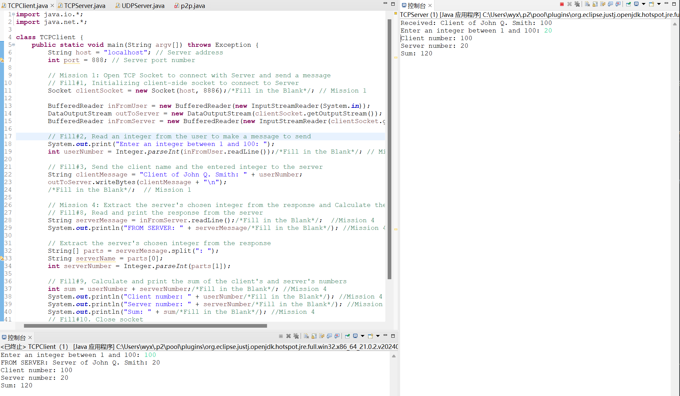

Instructions: How to run the program

Run server first, and run client.

How the program works
Server:

Initializes a TCP socket on a specified port (e.g. 8888).
Waits for a connection from a client.
After receiving a message from the client (containing a name and number), enter a number between 1 and 100.
Sends a response back to the client, containing the server's number.
Displays the results (client's number, server's number, and their sum) in the console.
Client:

Connects to the server using its IP address and port.
Prompts the user to enter an integer between 1 and 100.
Sends the user's number and the string to the server.
Receives the server's response and calculates the sum of the numbers.
Displays the server's number and the calculated sum.

